Below are listed several ways of handling deadlock:
(i) deadlock avoidance using say banker's algorithm
(ii) detect deadlock and kill a thread, releasing all its resources
(iii) reserve all resources in advance
(iv) if a thread needs to wait, release all resources and retry after sometime
(v) detect deadlock and roll back thread's actions
One criteria to use in evaluating different approaches to deadlock is which permits the greatest concurrency; in other words, which allows the most threads to make progress without waiting when there isn't a deadlock.
Give a rank order from (i) to (v) for each of the ways of handling deadlock listed below, where (i) allows the greatest degree of concurrency, and (v) allows the least

Q4 What are contiguous, indexed and linked allocations of files? Give their relative advantages over each other and also list situations of file access where one method would be preferred over other.

Which of the following are more like policies, and which are more like mechanisms? For each answer, circle policy or mechanism.
(a) The timer interrupt Policy / Mechanism (b) How long a time quantum should be Policy / Mechanism (c) Saving the register state of a process Policy / Mechanism (d) Continuing to run the current process when a disk I/O interrupt occurs Policy / Mechanism

Processes (or threads) can be in one of three states: Running, Ready, or Blocked. For each of the following four examples, write down which state the process (or thread) is in: (a) Waiting in Domain Read() for a message from some other process to arrive. (b) Spin-waiting for a variable x to become non-zero. (c) Having just completed an I/O, waiting to get scheduled again on the CPU. (d) Waiting inside of pthread cond wait() for some other thread to signal it

Consider the following C program. Assume there are no syntax errors and the program executes correctly. Assume the fork system calls succeed. What is the output printed to the screen when we execute the below program?
void main(argc, argv) { for(int i = 0; i < 4; i++) { int ret = fork(); if(ret == 0) printf("child %d\n", i); } }
Ans: The statement “child i” is printed 2 i times for i=0 to 3
What takes place during a system call?
To support trap handling, the OS has to set up a trap table of some kind; the trap table is used by the hardware to know which OS code to run when a particular trap occurs. How does the OS inform the hardware of the location of the trap table?
Timer interrupts are a useful mechanism for the OS. Why?

Three jobs (A, B, and C) arrive to the job scheduler at time 0. Job A needs 10 seconds of CPU time, Job B needs 20 seconds, and Job C needs 30 seconds. a) What is the average turnaround time for the jobs, assuming a shortest-job-first (SJF) scheduling policy? b) What is the average turnaround time assuming a longest-job-first (LJF) policy? c) Which finishes first, Job C in SJF or Job A in LJF?

Assume we manage a heap in a best-fit manner. What does best-fit management try to do? What kind of fragmentation can occur in this situation, and why is this bad?
Assume the following code snippet, where we have two semaphores, ’mutex’ and ’signal’: Thread 1 Thread 2
mutex.P(); mutex.P();
if (x > 0) x++;
signal.V(); signal.V();
mutex.V(); mutex.V();
signal.P();
We want ’mutex’ to provide mutual exclusion among the two threads, and for ’signal’ to provide a way for thread 2 to activate thread 1 when ’x’ is greater than 0. What should the initial values of each of the two semaphores be? (Assume that ’x’ is always positive or zero, and that there are only these two threads in the system).
Value of mutex: Value of signal:

A number of threads periodically call into the following routine, to make sure that a pipe that is shared between them has already been opened (after calling this routine, a thread might go ahead and call write() on that pipe, for example). Assume there is a global integer pipe, which is set to -1 when the pipe is closed, and a global lock lock, which is used for synchronization. Here is the code:
void MakeSurePipeIsOpen() { mutex_lock(&lock); if (pipe == -1) pipe = open(‘‘/tmp/fifo’’, O_WRONLY); mutex_unlock(&lock); }
However, you get clever, and decide to re-write the code as follows: void MakeSurePipeIsOpen() { if (pipe == -1) { mutex_lock(&lock); if (pipe == -1) pipe = open(‘‘/tmp/fifo’’, O_WRONLY); mutex_unlock(&lock); } }
Does this code still work correctly? If so, what advantage do we gain by using this implementation? If not, why doesn’t it work?

Assume we have a system that performs dynamic relocation of processes in physical memory. A process that has just started needs 2000 total bytes of memory in its address space. The OS currently has two free regions: the first between physical addresses of 1000 and 2000, and the second between physical addresses 5000 and 7000. What value would end up in the base register for this process, and what value would be in the bounds register? (write down any assumptions that you make about the bounds register) Value of base: Value of bounds:

In a system with pure paging, assume we have a 32-bit address space, and a 4 KB page size.
a) How many bits of an address specify the logical page number(a.k.a. the virtual page number), and how many bits specify the offset?
b) Let’s say we are translating the logical address 0x00010033; if each logical page is mapped to a physical page that is a single page number higher (i.e., logical page 10 is mapped to physical page 11, logical page 11 is mapped to physical page 12), what is the final translated physical address?

Assume we are in an environment with many threads running. Take the following C code snippet:
int z = 0; // global variable, shared among threads
void update (int x, int y) { z += x + y; }
Assume that threads may all be calling update with different values for x and y.
a): Write assembly code that implements the function update(). Assume you have three instructions at your disposal: (1) load [address], Rdest, (2) add Rdest, Rsrc1, Rsrc2, and (3) store Rsrc, [address]. Also, feel free to assume that when update() is called, the value of ’x’ is already in R1, and the value of ’y’ is in R2.
b): Because this code is not guarded with a lock or other synchronization primitive, a “race condition” could occur. Describe what this means.
c): Now, label places in the assembly code where a timer interrupt and switch to another thread could result in such a race condition occuring.
d): Now, assume we change the C code as follows: void update (int x, int y) { z = x + y; // note we just set z equal to x+y (not additive) } If two threads call update() at “nearly” the same time, the first like this: ’update(3,4)’, and second like this: ’update(10,20)’, what are the possible outcomes? If we place a lock around the routine (e.g., before setting z = x + y, we acquire a lock, and after, we release it), does this change the behavior of this snippet?

Envision a system that uses pure paging (i.e., no segmentation) and a hardware TLB. Also assume the the TLB is software managed, i.e., any updates to the TLB are handled by the operating system. • What happens on a TLB hit? • What happens on a TLB miss? • What happens on a page fault
In a traditional single-threaded process, we have both a stack and a heap. • What is the stack used for? • What is the heap used for? • If, for some reason, you could only have one of these two, which would you pick and why?
With dynamic relocation, the hardware has a base register and a bounds register, which it uses to support multiprogramming. • Imagine if you just had a base register; what functionality do you lose with the loss of the bounds register? • Imagine if you just had a bounds register; what functionality do you lose with the loss of the base register? • In a multiprogrammed system, if you could only have one such register, which would you choose, base or bounds? Why?
Name and describe two advantages that segmentation has over simple dynamic relocation

- In class, we talked about the following possible solution to the two-thread synchronization problem:
while (turn == (1 - threadlD))
; // spin
balance = balance + amount; // critical section
turn = 1 - threadlD;
In this solution, assume that "turn" is initialized to "0", and that there are only two threads that run. Does this solution provide mutual exclusion? (Explain)
- Some architectures provide instructions to aid with writing synchronization routines. One such instruction was "test-and-set", as described in class. Describe how test-and-set works; in doing so, show how one can use it to provide mutual exclusion.

- In class we discussed the following "solution" to the dining philosopher's problem:
acquire(int i) f
if (if < 4) {
sem wait(chop[i]);
sem wait(chop[i+1]);}
else {
sem wait(chop[0]);
sem wait(chop[4]);
}
}
Does this solution lead to deadlock? (Why or why not?)
- Reader/writer locks were implemented in class as follows, with the semaphores writeLock and mutex initialized to 1, and the counter readers initialized to 0.
void getWriteLock() { void releaseWriteLock() f
sem wait(writeLock); sem post(writeLock);
} }

void getReadLock() f
sem wait(mutex);
readers++;
if (readers == 1)
sem wait(writeLock);
sem post(mutex);
void releaseReadLock() f
sem wait(mutex);
readers--;
if (readers == 0)
sem post(writeLock);
sem post(mutex);
What is the basic problem that can occur if there is a continuous stream of readers that grab the read lock?
This question examines a disk’s internal scheduler as a black box, to see if we can learn anything about its behavior. The inputs we give to the disk are a bunch of requests; the outputs we observe are the order the requests are serviced. For example, we might issue requests to blocks 0, 100, and 200 at the same time. The disk might decide to service 100, then 200, and then 0, depending on its internal scheduling algorithm. We also know some details of the disk. It has one surface with 100 tracks, each of which have 100 sectors. The outer track (track=0) contains sectors 0...99, the next track (track=1) contains sectors 100...199, and so forth. In this question, each question gives a workload to a particular disk; you are then asked to determine what you think the scheduler of that disk is doing by servicing requests in that order. In other words, what can you say about the algorithm in use? What about the initial state of the disk, before the requests arrived? (a) Disk Model A Requests : 0, 1, 2, 3, 4, 5 Completed in order : 0, 1, 2, 3, 4, 5 What do you think Disk A’s scheduler is doing? What might the initial state of the disk have been? (b) Disk Model B Requests : 0, 500, 200, 400, 300, 100 Completed in order : 0, 100, 200, 300, 400, 500 What do you think Disk B’s scheduler is doing? What might the initial state of the disk have been? (c) Disk Model C Requests : 0, 500, 200, 400, 300, 100 Completed in order : 200, 300, 400, 500, 100, 0 What do you think Disk C’s scheduler is doing? What might the initial state of the disk have been? (d) Disk Model D Requests : 0, 50, 110, 600 Completed in order : 0, 110, 50, 600 What do you think Disk D’s scheduler is doing? What might the initial state of the disk have been? (e) Could these disks (A through D) actually be using the same scheduler? If so, why? If not, why not?
Q. Assume you have a hard-disk drive with these characteristics: 200 MB/s transfer rate, 9 millisecond (ms) maximum seek time, and 10,000 RPM speed of rotation. (a) When reading a 4KB block, what is the worst-case time for this hard drive? (b) What would you expect the average time to read a 4KB block to be? (c) When reading a 2MB block, what is the worst-case time for this hard drive? (d) What would you expect the average time to read a 2MB block to be? (e) Now assume you have a series of ten 4KB reads to perform on the disk. What series of ten reads would you send to the drive to get the worst case performance? (Assume the disk scheduler is FIFO) (f) How long will these ten requests take to complete? (g) Now assume you have a disk scheduler that performs shortest-access-time-first (SATF) scheduling. What ten requests could you send to the drive to get the worst case performance, given that the disk will re-order requests as per SATF? (h) How long will these ten requests take to complete?
Q. Files and directories provide a basic abstraction of persistent data to users. Here we explore (abstractly) how basic file systems work, focusing on links. Sometimes links lead to pretty odd performance problems. (a) Assume we have a regular file that is referred to by the pathname /a/b/c/orig.txt – how many directories will we access when opening this file? (b) Now assume we create a hard link to this file, as follows: ln /a/b/c/orig.txt /hard.txt. How many directories will we access when opening /hard.txt? (c) Is the file hard.txt a special type of file? (explain) (d) What happens to hard.txt when we delete orig.txt? Can we still access it? (explain) (e) Now assume we create a symbolic (soft) link to this file, as follows: ln -s /a/b/c/orig.txt /a/b/c/soft.txt. How many directories will we access when opening /a/b/c/soft.txt? (f) Is the file /a/b/c/soft.txt a special kind of file? (explain) (g) What happens to soft.txt when we delete orig.txt? Can we still access it? (h) Let’s say we create a symbolic link to a parent directory, as follows: ln -s /a/b/c /a/b/c/loop. How many different pathnames can we use to refer to the file orig.txt in the directory /a/b/c ?
Q. The very simple file system (VSFS) uses basic data structures such as a super block, bitmaps, inodes, and data blocks to store all relevant file system information. Assume further a multi-level index within each inode, with 12 direct pointers, one indirect pointer, and one double-indirect pointer. (a) You need to read a 4KB (one block) file, given its inode number. Assume no relevant structures are in memory in the file cache. How many disk accesses will the read take? (describe) (b) If this same file is read frequently, how many disk accesses will typically occur? (with caching) (c) Assume you need to append a block of size 4KB to a (small) file that already exists. Assume no relevant structures are in the file cache. How many disk accesses will the append take? (describe) (d) If this small file is appended to frequently, how many disk accesses will typically occur? (with caching) (e) Assume you need to append a block of size 4KB to a (large) file that already exists. Assume no relevant structures are in the file cache. How many disk accesses will the append take? (describe) (f) Assume you create a file in the root directory (e.g., /foo.txt). How many disk writes will take place (in the worst case)? (g) Assume you delete a file in the root directory (e.g., /foo.txt). How many disk writes will take place (in the worst case)?
Assume you are trying to figure out whether to poll a particular device or to use interrupts to get notified of device completion. When is one approach better than the other? (describe) (d) Could there be a situation where both polling and interrupts should be used? (describe)
// assume "balance" is a global variable
void update(int amount) f
mutex lock(lock);
balance = balance + amount;
mutex unlock(lock);}
However, there is one "rogue" thread that updates balance in a different way, by calling its own special routine:
// assume "balance" is a global variable
void rogue update(int amount) f
balance = balance + amount;}
When we are writing multi-threaded code, is there some way to prevent threads from accessing and updating shared data structures in this "rogue" fashion.

Q. Suppose you have to design an a file system for a user whose system usage is primarily listening to music, browsing web and sending/receiving emails. Describe what type of file system structure, the type of file allocation strategy and the disk scheduling algorithm you would use. Briefly state the reason for your choice/advantages of your design with other alternatives, especially in the context of its specific usage.

Dedicate some buffers for caching the MP3 tracks and prefetch them. Rearrangment of disk blocks to allow for whole tracks to be dedicated to MP3s is a good idea. Index allocation due to the frequency of request that are not sequential reads/writes (like the web and email requests). Disk scheduling should be any SCAN or LOOK or elevator algorithms. Just no FIFO.
Bonus points for people who say that they’ll have two queues and will put the MP3 requests in higher-priority queue.

Consider a secondary storage system of size 2 TB, with 512-byte sized blocks. Assume that the filesystem uses a multilevel inode data structure to track data blocks of a file. The inode has 64 bytes of space available to store pointers to data blocks, including a single indirect block, a double indirect block, and several direct blocks. What is the maximum file size that can be stored in such a file system?

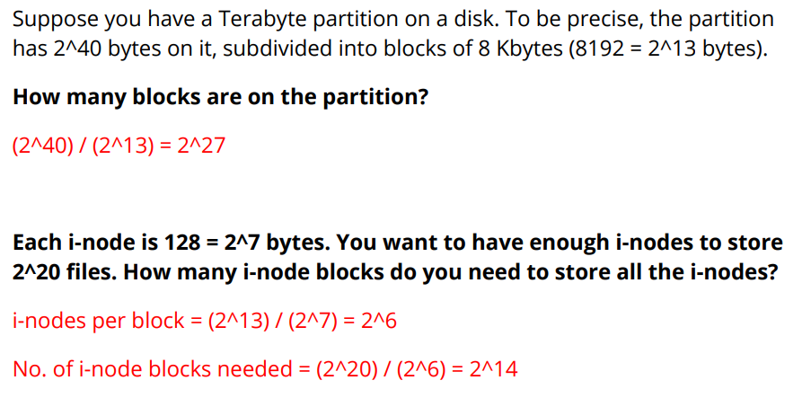

Q6. Suppose a new operating system file system uses index allocation of disk space. Stored with any file is an inode for the disk space allocation for that file. An inode contains only pointers, as many as 16. Every other block will contain either data or up to 16 pointers to other blocks (referred to as data blocks and index blocks respectively). A data block can store 512 bytes of data (0.5Kbytes).
The inode can have as many as 3 pointers to index blocks. Within an inode, pointers not used for pointing to index blocks are available for pointing to data blocks. The inode may have 1 pointer to another index block that has up to 16 pointers that point only to data blocks. The inode may also have 1 (indirect) pointer capable of pointing to data blocks via up to two levels of index blocks. The inode may also have 1 (double indirect) pointer) capable of pointing to data blocks via up to three levels of index blocks.
If we try to save a file with 16Kbytes of data, assuming that the system automatically eliminates redundant index blocks and redundant pointers (that is, more than the minimum number of required pointers do not occur).
(a) How many blocks of disk space will be required?
(b) How many pointers to data blocks will the inode have?
[3+3marks]
Ans: (a) 35 (b) 14
Q7. Suppose the read/write head is at track 97, moving toward track 199 (the highest numbered track on the disk) and the disk request queue contains read/write requests for sectors on tracks 84, 155, 103, 96 and 197, respectively. What is the total number of head movements to satisfy the requests using: (a) FCFS (b) SSTF (c) SCAN (d) LOOK [2+2+2+2 Marks]
Ans: FCFS
97 to 84 to 155 to 103 to 96 to 197 = 244
SSTF
97 to 96 to 103 to 84 to 155 to 197 = 140
SCAN
97 to 103 to 155 to 197 to 199 to 96 to 84 = 217
LOOK
97 to 103 to 155 to 197 to 96 to 84 = 213

Q. Given the disk to the right (which rotates counter clockwise), and assuming the requests are: 13, 4, 35, 34, 5, what request would be serviced last in the following disk scheduler algorithm. Assume a VERY FAST (essentially infinitely fast) seek wherever needed.
1 FIFO
2. SATF (shortest access first) scheduler
3. SSTF (shortest seek first)
How would you order the disk schedulers for those five requests, from fastest to slowest?

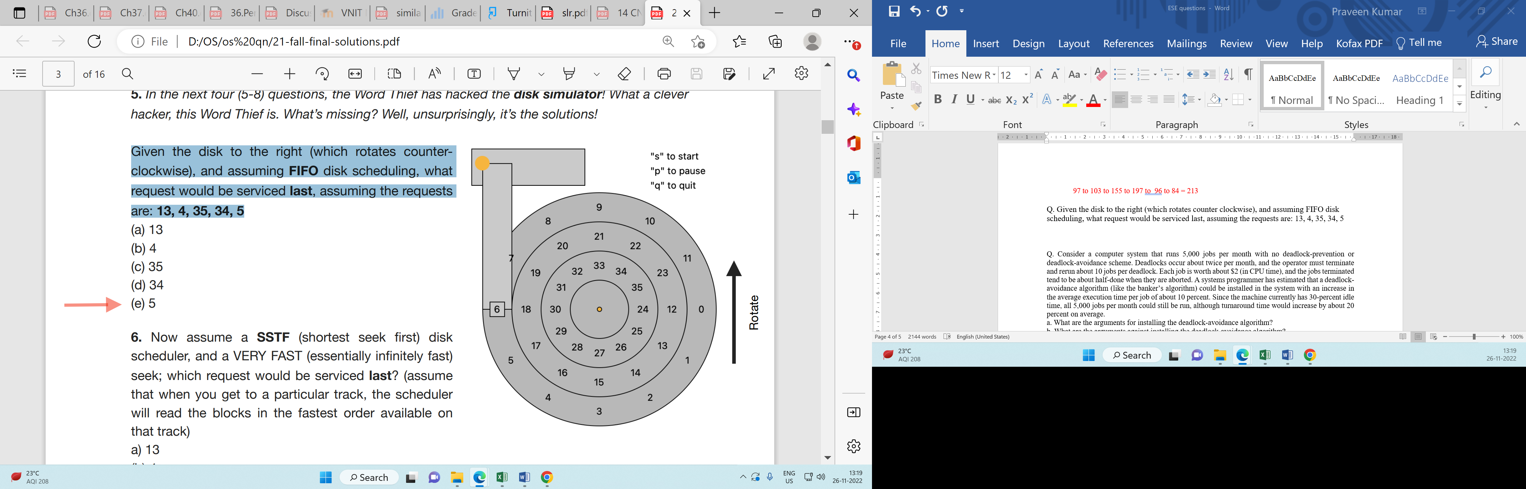
Q. what are the performance benefits of Write buffering?
batching, scheduling, and avoiding writes altogether

Suppose two threads execute the following C code concurrently, accessing shared variables a, b, and c:
Initialization
int a = 4; int b = 0; int c = 0;
Thread1
if (a < 0) { c = b - a; } else { c = b + a; }
Thread 2
b = 10; a = -3;
What are the possible values for c after both threads complete? You can assume that reads and writes of the variables are atomic, and that the order of statements within each thread is preserved in the code generated by the C compiler. For each value derived, show the instruction interleaving order too.
Answer: 4, 7, 13, 14, -3

Q on semaphore and deadlock
A1) The Nagpur Railway station bridge is undergoing repairs and only one lane is open for traffic. To prevent accidents, traffic lights have been installed at either end of the bridge to synchronize the traffic going in different directions. A car can only cross the bridge if there are no cars going the opposite direction on the bridge. Sensors at either end of the bridge detect when cars arrive and depart from the bridge, and these sensors control the traffic lights. Below is a skeleton implementation of two routines, Arrive() and Depart(). You may assume that each car is represented by a thread, and threads call Arrive() when they arrive at the bridge and Depart() when the leave the bridge. Threads pass in their direction of travel as input to the routines.

int num_cars = 0;
enum dir = {open, north, south};
dir cur_dir = open;

void Arrive (dir my_dir) {
A.0 while (cur_dir != my_dir ||cur_dir != open) ; /* Wait*/

A.1 num_cars++;
A.2 cur_dir = my_dir;
}

void Depart (dir my_dir) {
D. 1 num_cars--;
D.2 if (num_cars == 0) {cur_dir = open; }
}

(a) The code above does not have any synchronization statements. Outline an execution sequence (referring to the numbered statements) where two threads can cause two cars to travel on the bridge in opposite directions at the same time.
(b) Show how semaphore(s) could be used to correctly synchronize the cars by annotating the above routines using semaphores. Use the above routine structure as the basis for introducing the synchronization.
(c) Draw brackets around the sections of code that are critical sections.
(d) Can this solution lead to starvation? Briefly explain.
(e) Can this solution lead to deadlock? Briefly explain.
[3+3+3+3+3 Marks]
answer:
(a) Thread 1 (north): A.0, A.1 (context switch)
Thread 2 (south): A.0, A.1
and now we have two threads on the bridge in opposite directions.
(d) Yes. Once cars start moving in one direction, they will starve out cars waiting to go in the other
direction indefinitely (as long as more cars continue to arrive in the first direction).
(e) No, not all of the deadlock conditions are met (e.g., no circular wait). In specific terms, for
example, there is no way for cars going in both directions to wait at the same time.

